**IT17157674 – V.Aperame**

**4th Year 1st Semester, Cyber Security (CS) Batch**

**MLCS (Machine Learning for Cyber Security)**

**User Manual - Marriage Year Prediction**

**All the codes including for the Machine Learning Model as well as the code written for web application/ web page development are present in GitHub.**

To test the build model and project in the Localhost, for this, In PyCharm first the user need to run the “app.py” in order to up the server. Next, the user need to run the “index.html”. PyCharm is a community edition. So the user need to download it for free and need to install it in the PC (Personal Computer). And the version the user need to use is 2019.3.3. Also it is a Python editor. Rather than this, the user also need to import the Python Flask Server as well as need to install the Python.

Finally, in order to run the website, the user need to click the “Google Chrome” icon which is presented in the right hand corner side, in the “index.html” in PyCharm. (Figure 1) shows it.

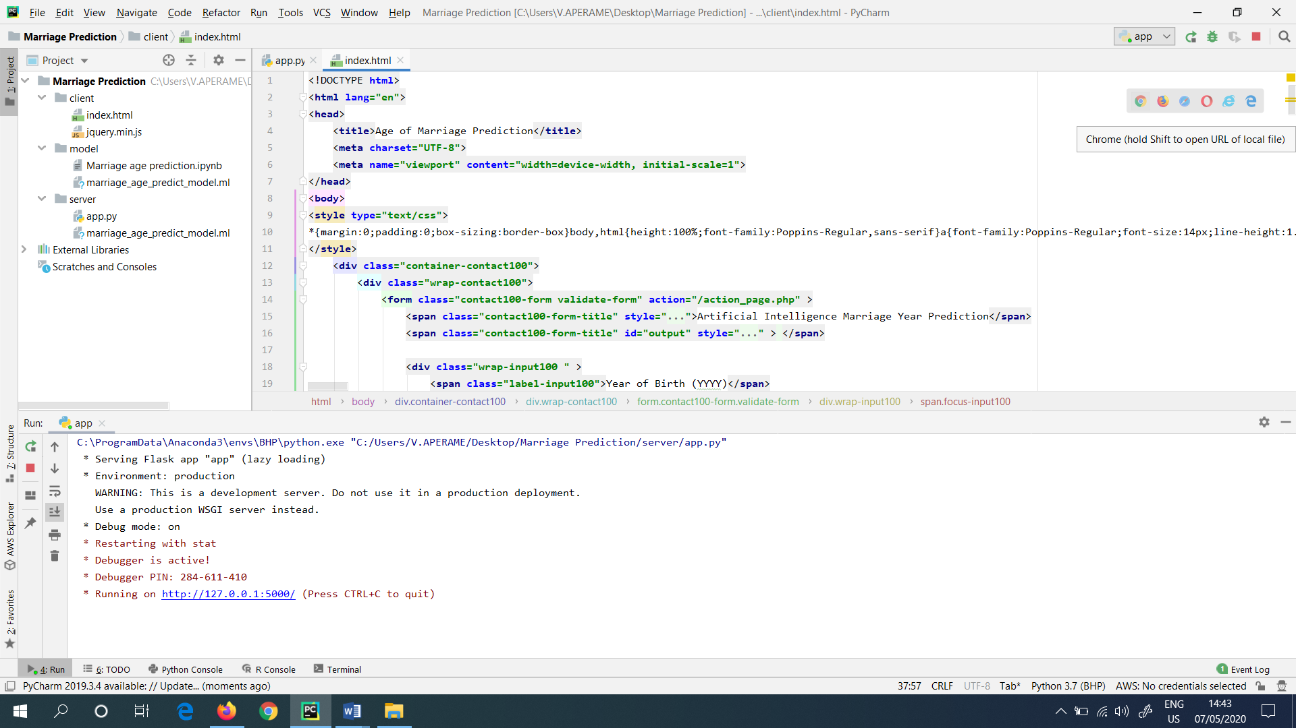

Figure 1: Clicked the Google Chrome icon in “index.html” file

**OR**

**There is another method (Second Method) presented, in order to run the project. This is explained below.**

The user directly goes to the “index.html” file, which is presented in the PC (Also in GitHub), and need to double click it in the file. This procedure also prompts the user, for a similar website which showed below. This is shown in (Figure 2). This is directly hosted in the local host of the PC (Personal Computer).

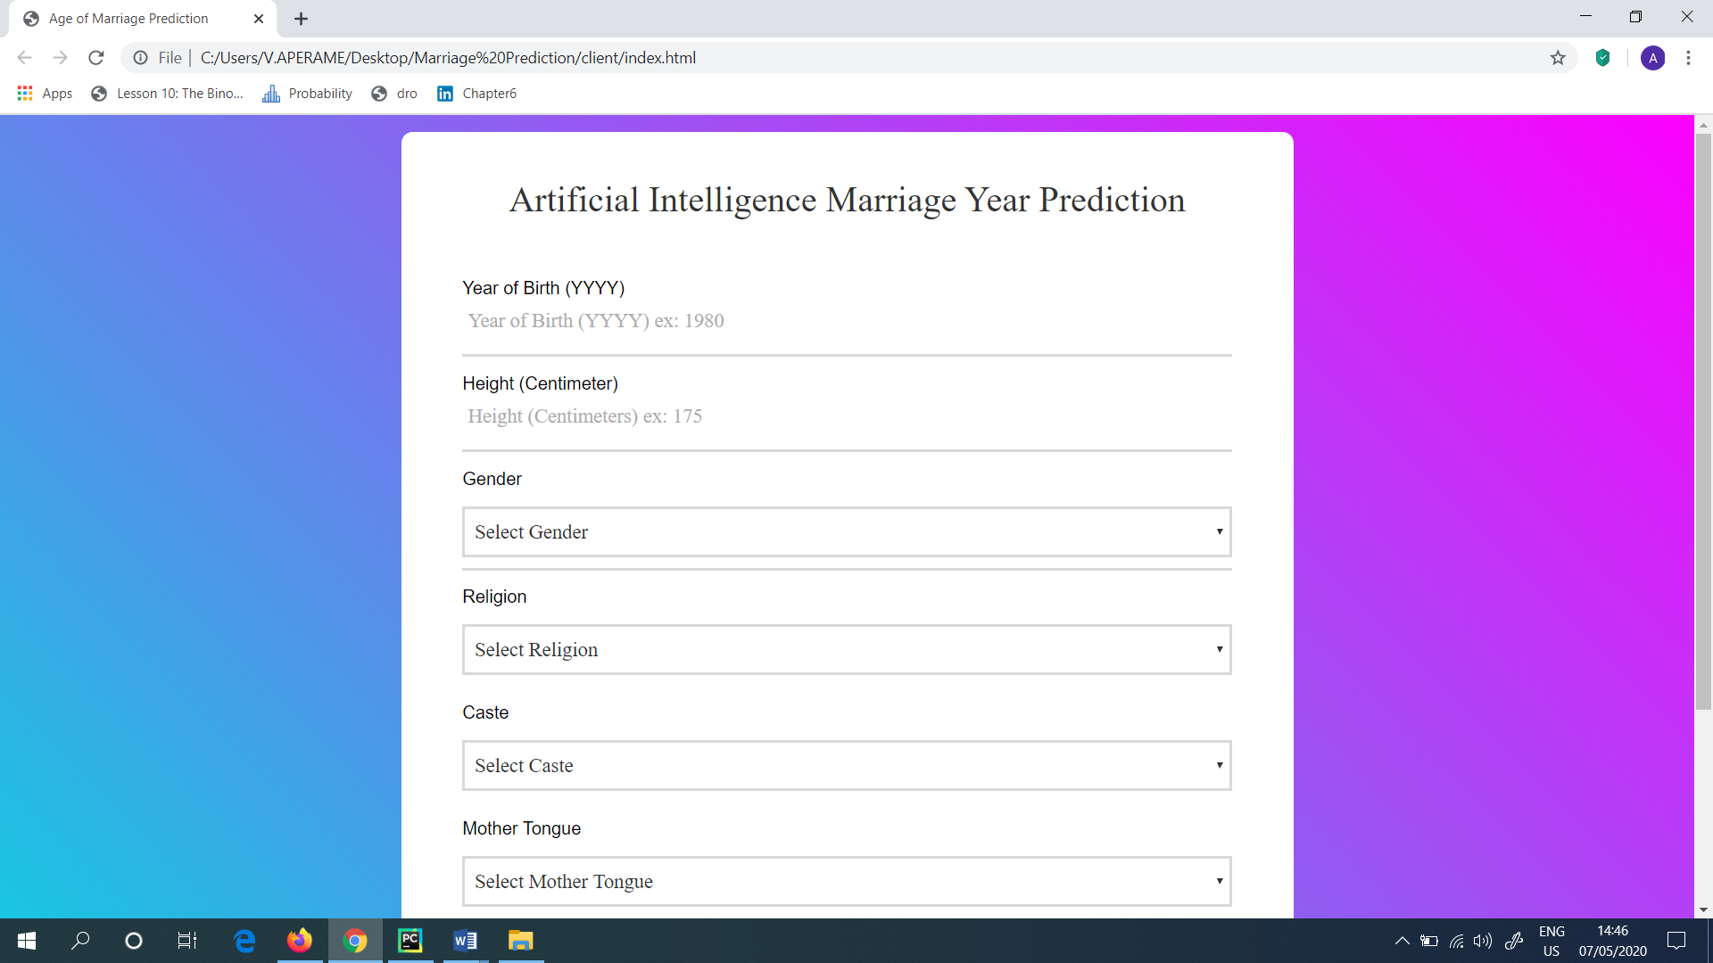

Figure 2: Got the same website by double clicking the “index.html” file

Next, when the user continued from the first method which is showed above, suddenly, in the Local host of PyCharm, the website which is created will be hosted as shown in (Figure 3). This is hosted with the help of the PyCharm.

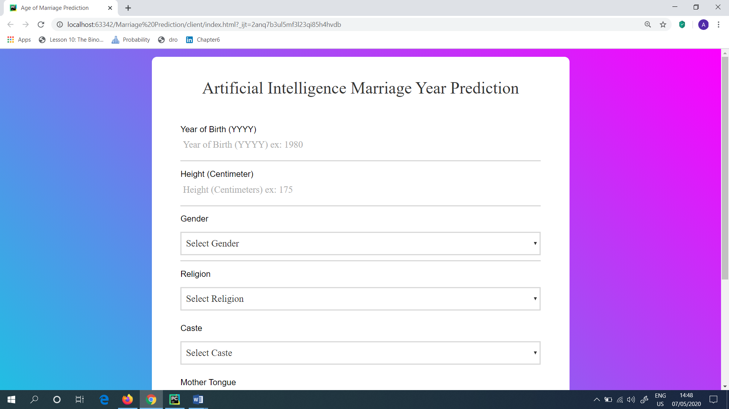

Figure 3: Website hosted in the localhost (PyCharm)

Then, the user need to check the model, whether it is working fine or not. So, as the input for the website, the user gave the following as shown in (Figure 4). I.e.: Year of Birth – 1993, Height (cm) – 175, Gender – Male, Religion – Hindu, Caste – Agarwal, Mother Tongue – Telugu and Country – India.

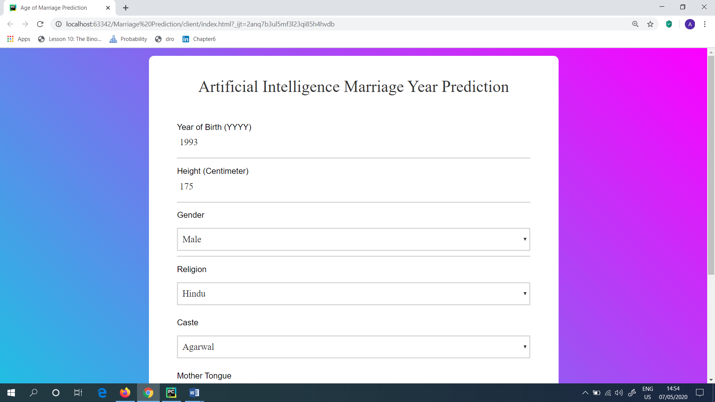

Figure 4: Checked the model with inputs given

In the Artificial Intelligence Marriage Year Prediction system, the Year of Birth is important in order to identify the predicted year of marriage. That is the reason the Year of Birth is also considered in this project.

The output, which the user will be gained while run this project, with the below mentioned inputs is shown in (Figure 5). Next, the user need to click the “Submit” button which is presented in the webpage to get the output.

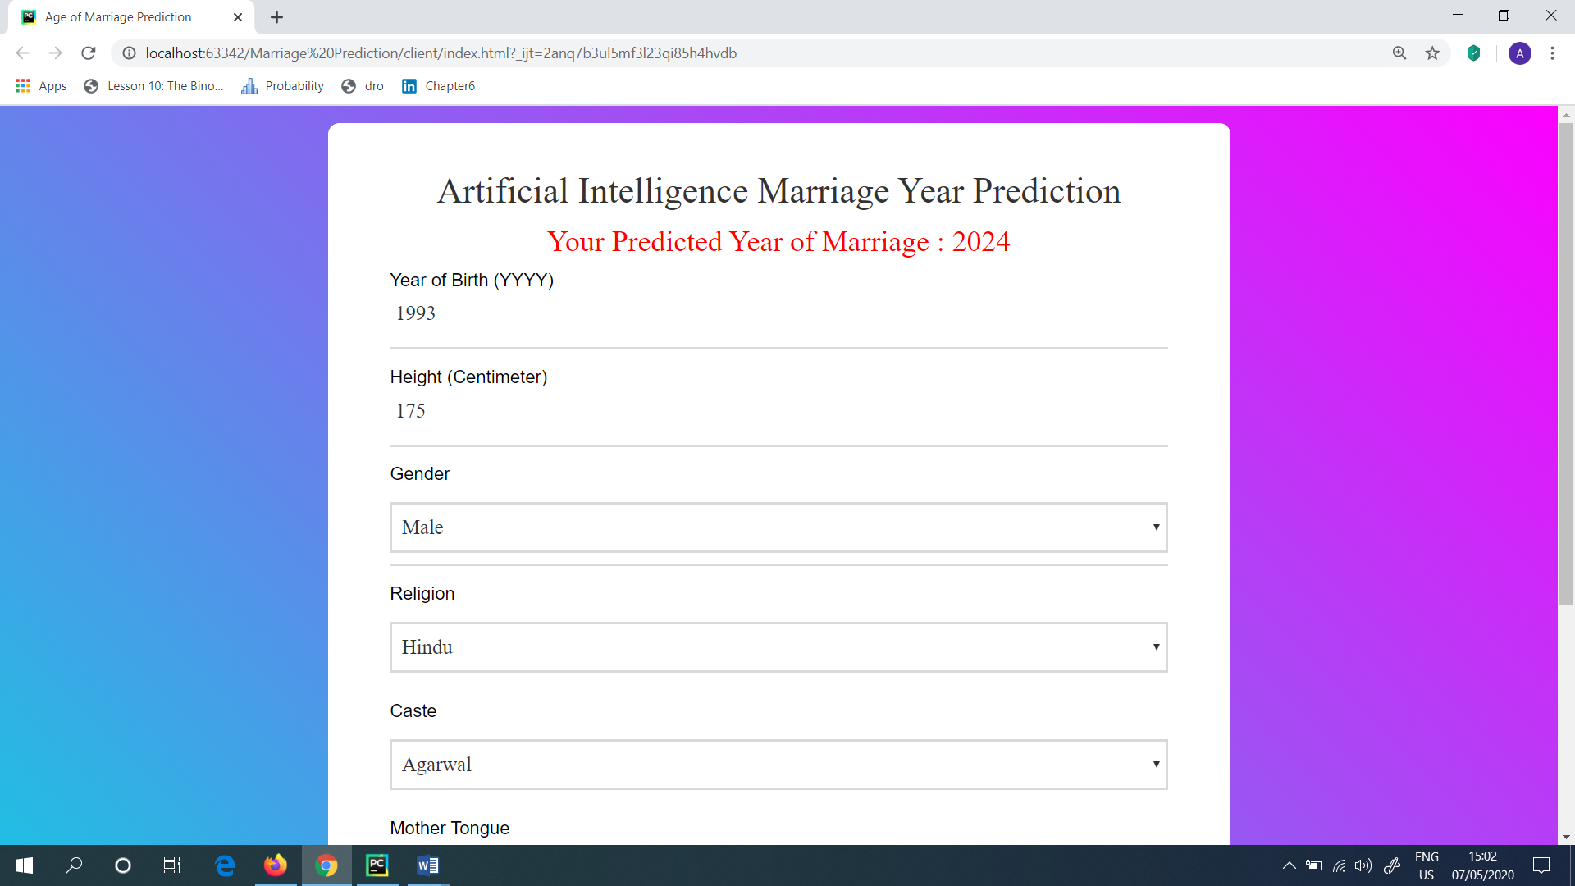

Figure 5: Output gained

Next, the user can try for the Predicted Year of Marriage, by giving different inputs. The model which is developed worked fine without any errors. Also the Predicted Year of Marriage got varied according to the user inputs which were given in the webpage.